Instructions for Delivering Sample App to Customers/Prospects

The Sample App folder has below two packages.

  - DMS Sample App
- This is the Java based sample app that can be deployed on customer premise.
- The sample app by default does not have any user authentication.

  - SSO Login Patch for DMS Sample App
- If there is a need to have an authentication for the Sample App, the sample app can be integrated to use the Policy Server’s default authentication.
- The patch will enable authentication screen for the sample app.
- Without the patch, accessing the sample app URL will directly the show the sample app landing page.
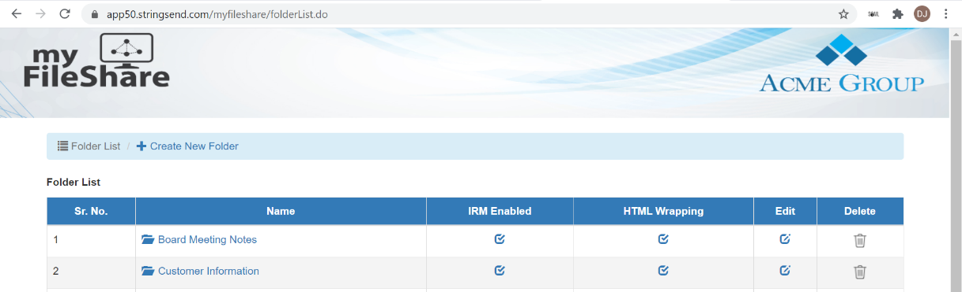
- With the patch, user will see an authentication page shown as below before accessing the sample app.

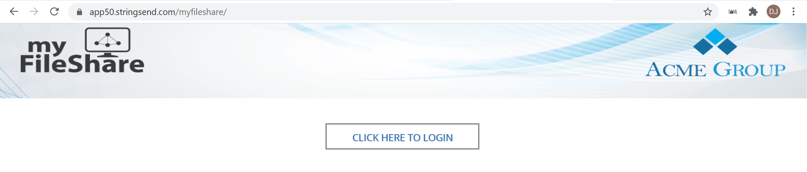

Important: While sharing the sample app with customers/prospects, you should always share only the package named “DMS Sample App”.
Only if there is a specific requirement of an authentication for the sample app, you can provide the package “SSO Login Patch for DMS Sample App”.

